Comprehensive Exam Study Guide

B.Ed. in Secondary Education –

Science concentration/Biology

Introduction
The College of Education administers a comprehensive exam to all students that they must pass with a score of 80% or better to be approved to enter student teaching/internship to ensure that students have the content, pedagogical, and professional knowledge needed to be successful in student teaching and in entering the teaching career.
Students take the exam just prior to student teaching/internship, and will not be allowed to register for student teaching/internship unless a passing score (> 80 %) has been obtained. Students will have two opportunities to pass the test.
The test is administered on Blackboard and students can get immediate feedback on their performance in the test.
In the following section, the guide offers a specification of the topics covered in the exam questions, the Qatar curriculum standards the questions are related to and sample questions for each concentration.
The exam consists of 60 multiple-choice questions. They are aligned to, and categorized by the Qatari curriculum standards for intermediate and secondary school levels. The curriculum standards covered in the exam are the following:

الموضوعات و المعايير التي ترتبط بها أسئلة الاختبار
Content | Standard | Question
Physical, Chemical, Cellular Basis of Life | 10.5.2 | 1
Physical, Chemical, Cellular Basis of Life | 9.7.2 | 2
Physical, Chemical, Cellular Basis of Life | 10.7.2 | 3
Physical, Chemical, Cellular Basis of Life | 9.12.4 | 4
Physical, Chemical, Cellular Basis of Life | 10.14.1 | 5
Continuity of Life / Changes of Organisms over Time | 10.11.2 | 6
Continuity of Life / Changes of Organisms over Time | 12.7.4  12.12.2 | 7
Continuity of Life / Changes of Organisms over Time | 9.5.4 | 8
Continuity of Life / Changes of Organisms over Time | 9.7.1 | 9
Continuity of Life / Changes of Organisms over Time | 9.7.1 | 10
Continuity of Life / Changes of Organisms over Time | 12.12.2 | 11
Unity and Diversity of Life | 10.10.1 | 12
Unity and Diversity of Life | 10.10.2 | 13
Unity and Diversity of Life | 11.5.3 | 14
Unity and Diversity of Life | 12.13.2 | 15
Unity and Diversity of Life | 11.8.2 | 16
Unity and Diversity of Life | 12.13.1 | 17
Ecological Relationships among Organisms | 11.16.1 | 18
Ecological Relationships among Organisms | 11.16.2 | 19
Ecological Relationships among Organisms | 10.22.4 (Chemistry) | 20
Physical, Chemical, Cellular Basis of Life | 10.11.2 | 21
Physical, Chemical, Cellular Basis of Life | 10.11.2 | 22
Physical, Chemical, Cellular Basis of Life | 9.7.2 | 23
Physical, Chemical, Cellular Basis of Life | 10.8.1 | 24
Physical, Chemical, Cellular Basis of Life | 12.5.1 | 25
Physical, Chemical, Cellular Basis of Life | 12.12.3 | 26
Continuity of Life / Changes of Organisms over Time | 10.12.2 | 27
Continuity of Life / Changes of Organisms over Time | 11.14.2 | 28
Continuity of Life / Changes of Organisms over Time | 11.17.4 | 29
Continuity of Life / Changes of Organisms over Time | 10.14.3 | 30
Continuity of Life / Changes of Organisms over Time | 12.12.3 | 31
Unity and Diversity of Life | 12.13.2 | 32
Unity and Diversity of Life | 12.13.1 | 33
Unity and Diversity of Life | 12.13.1 | 34
Unity and Diversity of Life | 10.14.2 | 35
Unity and Diversity of Life | 12.11.2 | 36
Unity and Diversity of Life | 8.10.2 | 37
Ecological Relationships among Organisms | 11.16.2 | 38
Ecological Relationships among Organisms | 11.7.1 | 39
Ecological Relationships among Organisms | 11.17.1 | 40
Physical, Chemical, Cellular Basis of Life | 11.5.1 | 41
Physical, Chemical, Cellular Basis of Life | 10.8.1 | 42
Physical, Chemical, Cellular Basis of Life | 11.9.2 | 43
Physical, Chemical, Cellular Basis of Life | 10.11.1 | 44
Physical, Chemical, Cellular Basis of Life | 11.6.1 | 45
Continuity of Life / Changes of Organisms over Time | 11.14.4 | 46
Continuity of Life / Changes of Organisms over Time | 11.16.5 | 47
Continuity of Life / Changes of Organisms over Time | 11.15.2 | 48
Continuity of Life / Changes of Organisms over Time | 10.13.1 | 49
Continuity of Life / Changes of Organisms over Time | 10.12.1 | 50
Continuity of Life / Changes of Organisms over Time | 11.14.4 | 51
Unity and Diversity of Life | 12.13.1 | 52
Unity and Diversity of Life | 9.5.1 | 53
Unity and Diversity of Life | 11.14.2 | 54
Unity and Diversity of Life | 8.10.1 | 55
Unity and Diversity of Life | 10.14.3 | 56
Ecological Relationships among Organisms | 10.14.1 | 57
Ecological Relationships among Organisms | 10.16.5 | 58
Ecological Relationships among Organisms | 10.16.2 | 59
Ecological Relationships among Organisms | 10.16.2 | 60

نماذج من الأسئلة
1 | ماذا يحدث لو فقدت الخلية العضية الموضحة في الشكل ادناه؟
 | A | تؤثر في انقسام الخلية
 | B | صعوبة في انتاج الطاقة
 | C | عدم القدرة على انتاج البروتين
 | D | نقص في هضم المواد الخلوية الزائدة

Qatar University

 | 2 |  | ما وظيفة التركيب المشار إليه بالرمز ( x )؟  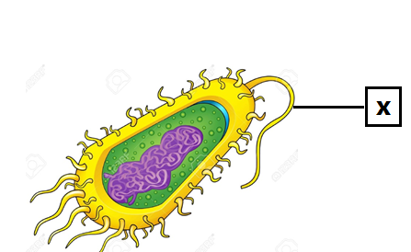
 |  |  | A |  | انتاج الطاقة
 |  |  | B |  | تصنيع البروتين
 |  |  | C |  | يساعد على الحركة
 |  |  | D |  | التعرف على الأجسام الغريبة
3 |  | كم عدد السنترومير الموجود في الخلية ، إذا كان عدد الكروماتيد 20 ؟
 |  | A |  | 10
 |  | B |  | 20
 |  | C |  | 30
 |  | D |  | 40

4 | ما الطور الذي يمثله الشكل أدناه في الانقسام المنصف للخلية ؟  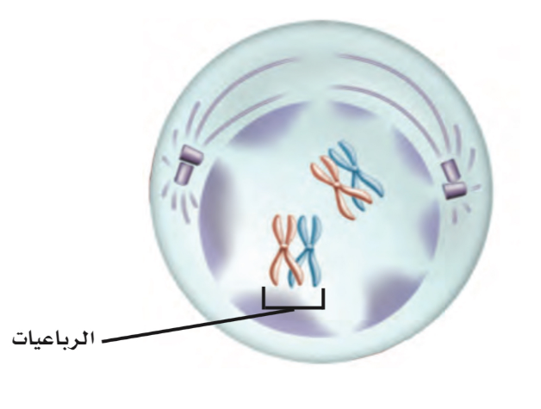
 | A | التمهيدي الأول
 | B | التمهيدي الثاني
 | C | النهائي الأول
 | D | النهائي الثاني

5 | أي الممالك التالية تتميز كائناتها بأنها متعددة الخلايا مع وجود جدار خلوي مكون من السيليلوز ؟
 | A | البدائيات
 | B | النباتات
 | C | الحيوانات
 | D | الطلائعيات

6 | أي الكائنات التالية تعتبر الأكثر كفاءة و سرعة في الحصول على الغذاء و التخلص من الفضلات؟  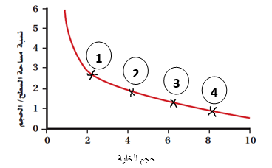
 | A | 1
 | B | 2
 | C | 3
 | D | 4

7 | ما التركيب الذي يمنع الرئتين من الاحتكاك بعظام القفص الصدري ؟
 | A | غشاء التامور
 | B | الغشاء البلوري
 | C | الحجاب الحاجز
 | D | العضلات بين الأضلاع

8 | ما القاعدة النيتروجينية المميزة لشريط RNA عن DNA؟
 | A | C
 | B | A
 | C | U
 | D | T

 | 9 |  | ما نوع الطفرة في الشكل (A)  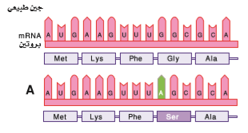
 |  |  | A |  | حذف
 |  |  | B |  | اضافة
 |  |  | C |  | استبدال
 |  |  | D |  | كروموسومية
10 |  | كيف تصنف بكتيريا لا تستطيع أن تتنفس إلا في وجود الأكسجين و تعطي لوناً أحمر مع صبغة جرام و تسبب مرض الكوليرا ؟
 |  | A |  | سالبة لصبغة جرام ، لا هوائية إجبارية ، عصوية .
 |  | B |  | موجبة لصبغة جرام ، هوائية إجبارية ، كروية .
 |  | C |  | سالبة لصبغة جرام ، هوائية إجبارية ، حلزونية .
 |  | D |  | موجبة لصبغة جرام ، لاهوائية إجبارية ، خيطية .

الأجوبة
Question Number | Standard Number | Answer Key
1 | 10.7.2 | A
2 | 10.7.1 | C
3 | 10.13.3 | A
4 | 11.13.1 | A
5 | 10.14.2 | B
6 | 11.7.1 | A
7 | 11.8.1 | B
8 | 10.11.1 | C
9 | 11.11.2 | C
10 | 11.14.1 | C

