Potential PhD Supervisors
College of Pharmacy
AY 2025

Mohamed Izham B. Mohamed Ibrahim, PhD  Professor of Social & Administrative Pharmacy  College of Pharmacy  QU Health  Building I – 06, Second Floor Room SA2.13  Qatar University, PO Box 2713, Doha, Qatar.  Tel: (+974) 4403 5580 (GMT +3hrs)  mohamedizham@qu.edu.qa | 
Research Area
Pharmaceutical policy and supply management, pharmaceutical economics, pharmacoepidemiology, socio-behavioral aspects of pharmacy & health and quality of life studies

Biography
Dr Mohamed Izham is a Professor of Social and Administrative Pharmacy at College of Pharmacy, Qatar University. He graduated with a bachelor's degree in Pharmacy (BPharm) from Universiti Sains Malaysia in 1990 and obtained PhD degree in Pharmacy Administration from the Philadelphia College of Pharmacy & Science (PCPS), Philadelphia, USA in 1995. Dr Izham’s previous positions include: Coordinator of Healthy Campus Program, Universiti Sains Malaysia; Director of the Corporate and Sustainable Development Division, Chancellory Department, Universiti Sains Malaysia; Deputy Dean of Research and Postgraduate Studies, School of Pharmaceutical Sciences, Universiti Sains Malaysia; and Professor and Chairman, Pharmacy Practice Department, College of Pharmacy, Qassim University, Al-Qassim, KSA. His last position was as the Associate Dean for Research and Graduate Studies Affairs at College of Pharmacy, Qatar University.

He has published over 300 peer-reviewed papers, multiple proceedings, monographs, research reports, bulletins, newsletters. He has also authored 10 books and multiple book chapters, presented more than 100 invited presentations worldwide, and is the recipient of 9 international, 21 national and 15 university research grants.

Dr. Izham has supervised and/or participated in the training of over 100 MSc and PhD graduate students from more than 10 countries. He has also functioned in multiple consultant roles to government and non-governmental bodies at national and international levels. He was also the recipient of the Universiti Sains Malaysia’s Award for Staff Excellence Service Award in 2004; Bintang Cemerlang Melaka (BCM) in 2004 from State of Malacca; Universiti Sains Malaysia’s Award for Publication Excellence in several years; Al Qassim University College of Pharmacy Excellence Professor Award 2010; and recently, Scopus awards recognized Dr. Mohamed Izham as one of Qatar University’s most distinguished researchers for his outstanding achievements. He won the 2015 Scopus Medical & Health Sciences Scientist Award.

PubMed: https://pubmed.ncbi.nlm.nih.gov/?term=mohamed+izham+mohamed+ibrahim
Google Scholar: https://scholar.google.com/citations?hl=en&user=uuUGCzkAAAAJ&view_op=list_works&sortby=pubdate
Scopus: https://www.scopus.com/authid/detail.uri?authorId=57195534191
ResearchGate: https://www.researchgate.net/profile/Mohamed_Izham_Mohamed_Ibrahim?ev=hdr_xprf
ORCID: https://orcid.org/0000-0001-9757-3574

Alaaldin M. Alkilany, PhD
BSc (Pharmacy) (Jordan University of Science and Technology, Jordan); PhD (University of Illinois at Urbana-Champaign, USA)
Professor of Pharmaceutics and Nanotechnology
Phone: +974 4403-5578
Fax: +974 4403-5551
Email: alkilany@qu.edu.qa
Research Area
Nanotechnology, Drug Delivery, Pharmaceutics, Industrial Pharmacy

Biography

Dr. Alkilany obtained his BSc in Pharmacy from Jordan University of Science and Technology in 2000 and then worked at Hikma Pharmaceutical (FDA-approved pharmaceutical manufacturer) as a formulation scientist in the Research & Development Department. Dr. Alkilany participated in the development and registration of more than twenty pharmaceutical products in regulated markets (the US and Europe). He then obtained his Ph.D. in Material Chemistry/Nanotechnology from the University of Illinois Urbana-Champaign (USA) in 2010 followed by postdoctoral training in the Pharmacology and Toxicology Department in Augusta University (USA). In 2012, Dr. Alkilany started his academic career as a faculty member at the School of Pharmacy (University of Jordan) and was appointed as the Director of Accreditation and Quality Assurance Centre.

Since 2021, is a Professor of Pharmaceutics and Nanotechnology at the college of Pharmacy at Qatar University and has a broad research interest including fabrication, functionalization, and biomedical applications of nanomaterials as well as Pharmaceutical product formulation and development of novel drug delivery systems.

According to Elsevier’s Scopus (Oct 2021), Dr. Alkilany has published more than 60 publications in international Journals with an h-index of 30 and more than 10 000 citations and supervised many MSc and Ph.D., graduate students. Dr. Alkilany is the recipient of the “Georg Forster Research Fellowship for Experienced Researchers” from the Alexander von Humboldt Foundation, Germany in 2017 and was featured in the World’s Top 2% Scientists List of Stanford University in 2020 (doi.org/10.1371/journal.pbio.3000918).

PubMed: https://pubmed.ncbi.nlm.nih.gov/?term=alkilany+alaaldin
Google Scholar: https://scholar.google.com/citations?user=QW-zKs8AAAAJ&hl=en

Muhammad Abdul Hadi, PhD  Pharm (Punjab University, Pakistan), MClinPharm (USM, Malaysia), PGCertHE (De Montfort University, UK), PhD (University of Leeds, UK)  Associate Professor of Clinical Pharmacy and Practice  College of Pharmacy  Room S2.10, I06 Building  E-mail: mabdulhadi@qu.edu.qa | 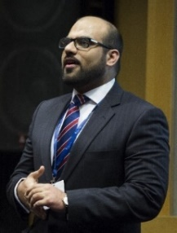
Research Area
- Pharmaceutical Health Services Research
- Medicines optimization
- Drug Safety
- Pharmacy Education

Biography
Dr. Muhammad Abdul Hadi is a pharmacist by training and obtained his undergraduate degree in Pharmacy from University of the Punjab, Pakistan. He went on to complete his Masters in Clinical Pharmacy (MClinPharm) from Universiti Sains Malaysia. He completed his clinical pharmacy training at Penang General Hospital. After completing his MClinPharm, he worked as a Lecturer in Clinical Pharmacy at Universiti Teknologi MARA, Malaysia. In 2010, he was awarded scholarship by the University of Leeds, UK to complete his PhD in pharmaceutical health services research.
Prior to joining Qatar University, he was a Senior Lecturer (Associate Professor) of Pharmacy Practice and Policy at the University of Birmingham, UK. At Birmingham, Dr. Hadi was the Programme Director of Independent Prescribing Programme and Chair of the School of Pharmacy’s Research Ethics Committee. In the past, he has held various academic positions at Malaysian, Australian and Saudi Arabian universities in addition to other universities in the UK.

Dr. Hadi’s main research interests include: health services research, medicines safety, use and optimisation and pharmacy education. He is a research methodologist and likes to work across different clinical disciplines. He has successfully supervised MSc and PhD students to completion. Dr. Hadi has published over 75 papers in international-peer reviewed journals. In addition, he has contributed chapters to various research methods and pharmaceutical policy books. The professor has presented his research work and chaired sessions at a number of international conferences. Dr. Hadi is also the Associate Editor of BMC Health Services Research and Journal of Pharmaceutical Policy and Practice. He is a mentor for the Pharmacy Research UK and faculty at the National Institute of Health Research (NIHR). He is a scientist member of the Royal Pharmaceutical Society and Fellow of the Higher Education Academy, UK.

PubMed: https://pubmed.ncbi.nlm.nih.gov/?term=Muhammad+Abdul+Hadi&sort=pubdate
Google Scholar: https://scholar.google.com/citations?user=iEJiSFMAAAAJ
Scopus: https://www.scopus.com/authid/detail.uri?authorId=57217032113

Kazeem Babatunde Yusuff, PhD  BPharm, MPharm (Clinical Pharm), PhD (Clinical Pharm) (Nigeria)  Associate Professor of Clinical Pharmacy and Practice  College of Pharmacy  Qatar University  kyusuff@qu.edu.qa | 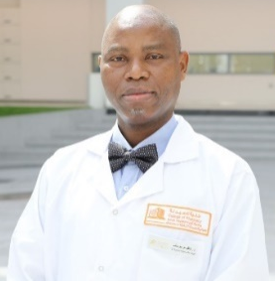
Research Area
Pharmacoepidemiology, Pharmaceutical care, Community Pharmacy Practice and Pharmacy Education

Biography
Dr. Kazeem Babatunde Yusuff is an associate professor with a rich career history traversing different areas of pharmacy practice including hospital pharmacy, medical marketing, public health and pharmacy education / training where he is currently engaged. He obtained his Bachelor of Pharmacy (Hons) from the University of Ife, now Obafemi Awolowo University in 1987, Master of Pharmacy (Distinction) and Doctor of Philosophy from the University of Lagos, Nigeria 2000 and 2008 respectively. He has an unrelenting focus and passion for high quality researches within the context of clinical pharmacy and practice that are laser-focused on the linkage of theory with practice, and clear identification of meaningful contributions that pharmacists can make to ensure effective and safe use of medicines at the individual, institutional and societal levels. Dr. Yusuff’s research areas include pharmacoepidemiology, pharmaceutical care, evidence-based practice, deprescribing, medicine advertisement, medication history, pharmacy education and community pharmacy practice. He has supervised several research projects at both undergraduate and postgraduate levels, and has also served as internal and external examiner for master’s projects in both Nigeria and South Africa. Dr. Yusuff has published 33 original research articles in varieties of leading high quality reputable peer-reviewed national and international journals. He is currently serving as an Academic / Associate Editor of the PLOS ONE and BMC Health Services Research. In addition, he continues to serve as a peer reviewer to several reputable international journals in the area of clinical pharmacy and pharmacy practice. Dr. Yusuff currently serves on several committees at the college level and he is currently the chair of the Programme Learning Outcomes Assessment Committee in the College of Pharmacy at Qatar University.

PubMed: https://pubmed.ncbi.nlm.nih.gov/?term=Yusuff%20K%20
Google Scholar: https://scholar.google.com/citations?view_op=list_works&hl=en&user=ZSatF7QAAAAJ

Daoud Al-Badriyeh, PhD  BPharm Honors (Uni of Sydney, Australia), PhD (Monash Uni, Australia)  Associate Professor of Pharmacoeconomics and Outcomes Research  College of Pharmacy, QU Health  Qatar University  Daoud.a@qu.edu.qa | 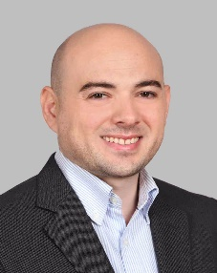
Research Area
Pharmacoeconomics, Health economics, Decision-analytic modeling and simulation, Comparative clinical effectiveness research

Biography
Dr. Daoud Al-Badriyeh completed an honors degree in pharmacy at the University of Sydney (Sydney, Australia), and then received his PhD in pharmacoeconomics from Monash University (Melbourne, Australia). Dr. Daoud also completed specialized training in healthcare analytics, patient safety and medical errors, and medical statistics.
Currently, Dr. Daoud is a Professor of Pharmacoeconomics and Outcomes Research and is the Head of Graduate Studies at the College of Pharmacy of Qatar University, Qatar, and is an adjunct faculty member at Monash University, Australia.
Dr. Daoud published over 80 peer-reviewed research articles, he has over 50 peer-reviewed published conference proceedings, and has over 145 conference presentations. He supervised over 20 postgraduate students so far, including current MSc and PhD students, and has over QAR 6 Million in accumulated research funds.
Dr. Daoud’s research mainly focuses on pharmacoeconomics, health economics, and decision-analytic simulation, as well as comparative effectiveness research and the economic impact of hospital services.
Dr. Daoud is also the Founder and current President of the Qatar Chapter of the International Society of Pharmacoeconomics and Outcomes Research (ISPOR, USA). He is also the Lead of the Health and Business Research Network Group at Qatar University, Qatar.

College webpage, including postgraduate research interests: http://qufaculty.qu.edu.qa/daoud-a/
PubMed: https://pubmed.ncbi.nlm.nih.gov/?term=al-badriyeh&sort=date
Google Scholar: https://scholar.google.com/citations?user=oxS4bikAAAAJ&hl=en

Nashiru Billa, BPharm; PhD  Professor of Pharmaceutics  College of Pharmacy  Qatar University  E-mail: nbilla@qu.edu.qa | 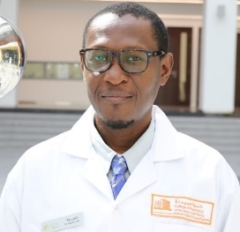
Research Area
Drug delivery; Nano-formulation; Pharmaceutical technology
Biography
Dr Billa is a Professor of Pharmaceutics at the College of Pharmacy, Qatar University. He is a Pharmacist and obtained his PhD in Pharmaceutical Technology from the University of Science, Malaysia in 2000, after a brief an attachment at a Pharmaceutical Industry. He Joined the International Medical University in 2001 as a Lecturer in Pharmaceutics and the Chief Scientist of the EQUILAB Bioequivalence laboratory in the same University, where he oversaw the execution of bioequivalence studies to Pharmaceutical Industries. In 2005, He joined the School of Pharmacy, University of Nottingham, Malaysia Campus as an Assistant Professor and was promoted to Associate Professor in 2007 and to full Professor in 2015. During his 15-year engagement at the University of Nottingham, he held several administrative positions, including Associate Dean for Research & Knowledge Exchange and Deputy Head of School.
Dr Billa is recipient of numerous University, National and International grants, including a Euro FP7 Bio-design collaborative research grant worth 1million euros aimed at deciphering the fate of growth factors in bone tissue engineering. He has served as a consultant to a Pharmaceutical Company and participated more than 32 bioequivalence studies on generic pharmaceuticals products to sponsors. He has published over 70 peer-reviewed journals, supervised 2 Postdoctoral candidates, 15 PhD and 9 MSc candidates as primary supervisor. He has also served as External Examiner to 18 PhD student theses.
Dr Billa’s research interest is primarily aimed at improving the bioavailability of drugs via novel technologies such as nanoparticle formulation. Emphasis is on the use of natural therapeutics of plant origin, especially anticancer agents and the use of biodegradable/biocompatible excipients and oral delivery of developed nanoparticle formulations. These are typically polymeric, solid lipid and nanostructured lipid carriers (SLN & NLC). He is also interested in the application of in vitro and in vivo models in understanding the performance of nanoparticle deployment into and across epithelia. Other research interest involve the application of 3D printing technology in the development of drug delivery systems and biomedical devices.

PubMed: https://pubmed.ncbi.nlm.nih.gov/?term=nashiru+billa
Google Scholar: https://scholar.google.com/citations?user=eW3jcVYAAAAJ&hl=en
Scopus: https://www.scopus.com/authid/detail.uri?authorId=6508377305

Hesham M. Korashy, PhD  BSc (Pharmaceutical Sciences), PhD (Pharmacology and Toxicology) (U of Alberta, Canada)  Professor of Pharmacology and Toxicology  College of Pharmacy  Qatar University  E-mail: hkorashy@qu.edu.qa | 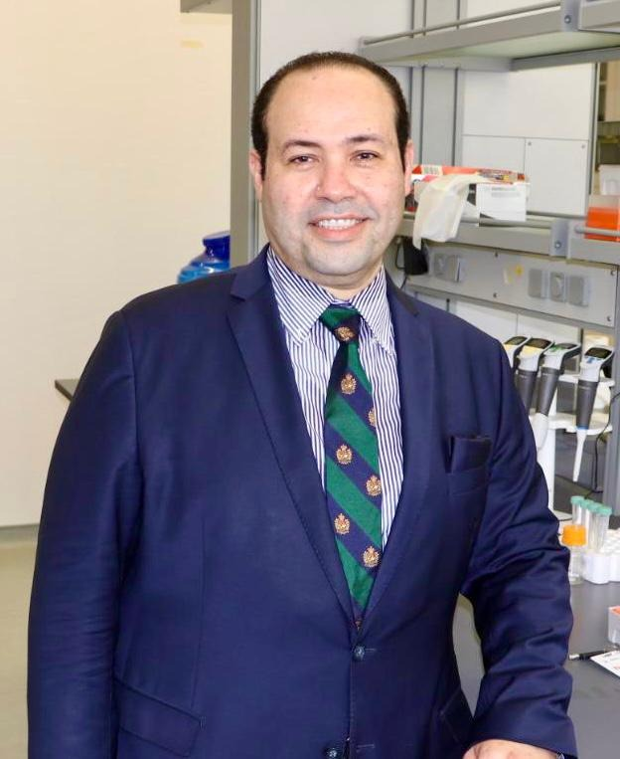
Research Area
Molecular Oncology of cancer stem cells and Environmental toxicology
Biography
Dr. Korashy is a Professor of Pharmacology and Toxicology in the Department of Pharmaceutical Sciences at the College of Pharmacy. He holds a Ph.D. degree in Pharmacology and Toxicology from the University of Alberta (Edmonton, Canada) and a bachelor’s degree in Pharmacy from King Saud University (Riyadh, Saudi Arabia). Dr. Korashy joined the department of Pharmacology and Toxicology at the College of Pharmacy, King Saud University as an Assistant Professor (2008-2012), and then as an Associate Professor (2012-2017), before he joined Qatar university as a full Professor in 2017. Currently, He serves on several committees at the university level as the Chair of the Institutional Committee for Animal Care and Use (QU-IACUC) and Co-Chair of the Academic Promotion Committee, in addition to other committees at the college level.

Dr. Korashy has more than 15 years of experience in teaching pharmacology and toxicology courses to undergraduate and postgraduate students at the colleges of pharmacy, medicine, and health sciences. Dr. Korashy has a well-established reputation for research in molecular oncology of cancer stem cells and environmental toxicology at the regional and global levels. His main research interests focus on understanding the role and function of aryl hydrocarbon receptor transcription factor and cytochrome P450 1A1 and 1B1 in cancer stem cell development, self-renewal, and progression aiming at designing novel chemoprotective strategies. He is also interested in studying the impact of exposure to air pollutants and environmental toxins on disease development. He secured several research grant funds exceeding two million Qatari riyals as an LPI, funded by Qatar University and the Qatar National Research Fund. He also has many research partnerships and collaborations with top researchers in prestigious universities in Canada, the USA, Oman, and Saudi Arabia.

Dr. Korashy has published more than 90 peer-reviewed articles in high-impact index journals, such as Molecular Cancer (IF=44.4), and Seminars in Cancer Biology (IF=17). His research work has been presented at many national and international pharmacology and toxicology conferences and meetings. He has supervised more than 19 MSc and PhD theses in pharmacology and toxicology. Dr. Korashy serves as Associate Editor of the Journal of Translational Medicine and Frontiers in Pharmacology and a member of the editorial board of several scientific journals.

PubMed: https://pubmed.ncbi.nlm.nih.gov/?term=korashy+h&sort=date
Google Scholar: https://scholar.google.com/citations?user=vwLn7bAAAAAJ&hl=en
ORCID: https://orcid.org/0000-0002-5745-9643

Hazem Elewa, PhD  Academic degrees: PhD  Associate Professor, Head of Clinical Education  College of Pharmacy  Department of Clinical Pharmacy and Practice, Qatar University  E-mail: Hazem.elewa@qu.edu.qa | 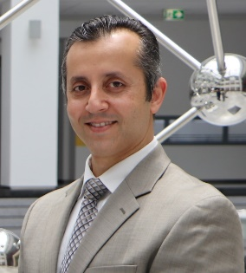
Research Area
The mission of the cardiovascular pharmacogenomics and Precision medicine is to train graduate students and researchers on performing pharmacogenomics studies including different genotyping techniques and the clinical applications of genetics especially in the field of cardiovascular disease.
Our ultimate goal is to spread the knowledge on the applications of genetics in the healthcare system and to launch a pharmacist-led pharmacogenetic service at Hamad Medical Corporation, the main care provider facility in Qatar. Aside from genomics, our group has conducted multiple clinical research studies in the area of cardiology and anticoagulation.

Biography
Dr. Hazem received his Bachelor degree in pharmacy from Alexandria University, Egypt in 2000, then PhD from University of Georgia (UGA) in 2008. He joined University of Florida for a one year post-doctoral fellowship in pharmacogenomics. Since October 2010, Dr. Hazem served as a Clinical Pharmacist at Georgia Regents Medical Center and was appointed as a Clinical Assistant Professor at the University of Georgia, College of Pharmacy as well as a clinical rotation preceptor since 2011.
Dr. Elewa currently works as the Head of Clinical training and is Associate Professor at the College of Pharmacy, Qatar University. His clinical practice is focused on Cardiology and anticoagulation. His research interest includes anticoagulation and precision medicine in cardiovascular diseases through the use of pharmacogenetics. He received several awards including a pre-doctoral fellowship grant from the American Heart Association and multiple grants through Qatar National Research Foundation and Hamad Medical Corporation. To date he has published more than 60 peer-reviewed papers and was invited speaker at different international conferences. He supervised several MSc & PhD students at the College of Pharmacy. Dr.Elewa also serves as a board member in the International Pharmacists Anticoagulation Care Taskforce (iPACT) and a reviewer for several international peer-reviewed journals.

Google Scholar: https://scholar.google.com/citations?hl=en&user=UO2tpmAAAAAJ&view_op=list_works&sortby=pubdate
ResearchGate: https://www.researchgate.net/profile/Hazem_Elewa

Abdelbary Elhissi, PhD  BSc (Pharmacy); PhD (Pharmaceutics), HE Cert (Teaching & Learning)  Full Professor  College of Pharmacy  Department of Pharmaceutical Sciences, College of Pharmacy (I06), Qatar University, P.O. Box 2713, Doha, Qatar  E-mail: aelhissi@qu.edu.qa | 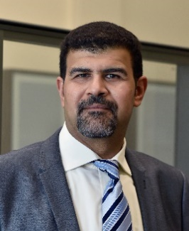
Research Area
Pharmaceutics, Drug delivery systems, Nanomedicine, Clinical Pharmaceutics

Biography
Dr Abdelbary Elhissi is a leader in higher education with powerful experience in research excellence, strategy, and innovation, and is currently a Full Professor in Pharmaceutics and classified among the top 2% world scientists in terms of subject citation impact (Stanford University Reports).

Abdelbary obtained his PhD in 2005 from the School of Pharmacy, University College London (UCL) where he then worked as a Post-Doctoral Research Fellow (2005-2006). He worked in pharmaceutical industry’s R&D at Lipoxen Technologies, as Senior Scientist for the development of anticancer nanomedicines (2006-2007). Abdelbary joined the University of Central Lancashire (UCLan) in UK as Lecturer (2007- 2011) and Senior Lecturer (2011-2014), where he was the lead of Pharmaceutics and established one of the largest drug delivery research groups in the UK. He was the Deputy Head and a founder of the UCLan’s Institute of Nanotechnology and Bioengineering (2011-2014).

Abdelbary moved to Qatar University as Associate Professor at the College of Pharmacy in 2014 and was promoted to Professor in 2019. Parallel to this, Abdelbary is the Founding Manager of the Research Excellence Office (July 2017 – May 2020), and served as Director of Research Planning and Development (June 2020 – May 2022).

Abdelbary authored more than 100 peer-reviewed publications and book chapters and published 3 books, supervised more than 25 MSc and PhD students, and secured approx. USD 2.5 Million for his research. Abdelbary teaches in a range of undergraduate and graduate courses in areas of Pharmaceutics, Pharmaceutical technology, advanced drug delivery, and topics related to pharmaceutical industry. Abdelbary is a Certified Knowledge Manager (CKM), and served as a Visiting Professor at Sichuan University, China (2013-2016). He also served as an External Examiner (Reviewer) of the MPharm Program at University of Ulster, Northern Ireland, UK (2013-2017), a PhD external examiner at Manchester Metropolitan University (2014) and a Visiting Professor at Anglia Ruskin University, UK (Feb 2022- present).

PubMed: https://pubmed.ncbi.nlm.nih.gov/?term=Elhissi
Google Scholar: https://scholar.google.com/citations?hl=en&user=eEHe5gIAAAAJ
Linkedin: https://qa.linkedin.com/in/professor-abdelbary-elhissi-99b92911a

Ousama Rachid, PhD  BSc (Pharmacy), PhD (Pharmacokinetics, U of Manitoba, Canada)  Associate Professor  College of Pharmacy  QU Health, Qatar University  E-mail: orachid@qu.edu.qa | 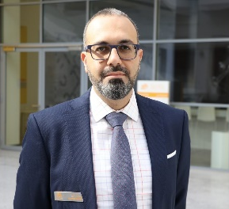
Research Area
Solid dosage form development, pharmacokinetics profiling, and in silico predictions

Biography
Dr. Rachid has extensive expertise in the development, characterization, and pharmacokinetic profiling of orally disintegrating sublingual tablet formulations with incorporation of drug nanoparticles in a preclinical animal model. With an international team, Dr. Rachid co-invented several patents with licensing potential of novel nanoparticles of epinephrine for the first-aid treatment of severe allergic reactions in community settings. Dr. Rachid has attracted over 800,000 USD of funding, published a good record of peer-reviewed articles and conference proceedings in the in vitro and in vivo preclinical studies in the field of drug delivery and nanomedicine in high-impact international journals.
Dr. Rachid’s research is focused on R&D of innovative drug products, with commercialization potential. His career objective is fine-tuned around generating effective drug delivery systems and affordable dosage forms to solve therapeutic problems and improve therapeutic outcomes. Dr. Rachid has been heavily involved in conducting in vivo animal studies in rabbits, developing essential skills in experimental and protocol design (crossover, parallel), drug absorption and bioavailability/ bioequivalency studies, intravenous (IV) catheterization into rabbit ear marginal vessels, intramuscular (IM) injections in thigh, sublingual (SL) administration in SL cavity using a speculum, plasma separation using vacutainer PST tubes, and development of in vitro-in vivo correlations. Dr. Rachid’s laboratory research team uses the most up-to-date pharmacokinetics software such as Phoenex, Certara WinNonLin to analyze multiple profiles, noncompartmental analysis, pharmacokinetic modeling, and bioequivalence. His laboratory is well-established and equipped with sample preparation and analytical instruments including solid phase extraction using manually-activated and ready-to-use alumina cartridges and vacuum manifold, development of mobile phases and qualifying methods, HPLC systems (Waters® systems, Agilant system, and Shimadzu system) with UV, PDA, EC and MS detectors.
Current trends in Dr. Rachid’s research include the in silico-guided screening of potential drug candidates, ADMET predictions, and pharmacokinetic modeling and simulations using machine learning software tools as deemed standard by big pharma. In addition, Dr. Rachid is currently leading a country wide study on mapping the environmental conditions and stability evaluation of medications used in the Ambulance Service in HMC.

PubMed: https://pubmed.ncbi.nlm.nih.gov/?term=ousama+rachid&sort=date
Google Scholar: https://scholar.google.com/citations?user=6dL7oSwAAAAJ&hl=en&oi=ao

Hassaan A. Rathore, PhD  B.Pharm, PhD  Associate Professor  College of Pharmacy  Qatar University  hrathore@qu.edu.qa | 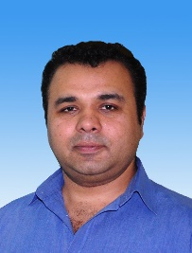
Research Area
Neurohumoral control of cardiovascular & renal function, obesity, diabetes & anti-oxidant research

Biography
Dr. Hassaan Rathore is an Associate Professor at the College of Pharmacy, Qatar University. He completed his bachelors in pharmacy from University of The Punjab, Lahore, Pakistan in the year 2001 and was awarded a doctorate degree in the field of physiology/pharmacy by the Universiti Sains Malaysia (USM), Penang in year 2009 where he served as a senior lecturer at the School of Pharmaceutical Sciences, until 2017. Previously, he has worked as an Associate Professor and Head of the Department of Pharmacology & Toxicology, the Pharm D Program Coordinator and was a member of the strategic planning committee at the University of Hail, KSA.
Dr. Rathore has published more than 55 research publications in renowned journals indexed and graded by ISI and Scopus and other well-known databases along with several conference proceedings, research reports and has contributed several book chapters. Dr. Rathore has supervised 5 MSc and 6 PhD students who are now successful academicians, researchers and serving different governmental and non-governmental organizations in Malaysia, Pakistan, USA, Libya and other countries.
He has keen interest in improving teaching-learning techniques especially in teaching of physiology to pharmacy students. He has been an active member of Physiology teaching group formed at IUPS 2009 in Kobe, Japan and has been a full member of the American Physiological Society, The Physiological Society UK since 2008 and served as an editor to a quarterly newsletter of the Malaysian Society of Pharmacology and Physiology from 2005 to 2012.
Dr. Rathore’s expertise is teaching human physiology and researches via In vivo experimentation in cardiovascular & renal research areas. He has extensive experience in surgical manipulation of small animals including cannulation of carotid & iliac artery, jugular vein, tracheotomy etc. Surgical & chemical induction of different diseases such as left ventricular hypertrophy, heart failure, renal failure; hypertension models, diabetes, metabolic syndrome etc. were routinely developed in his laboratory. He also has extensive experience in the use of PowerLab® research and teaching systems, Millar’s PV catheters and MPV systems, small animal ECG, metabolic studies, renal and cardiovascular function studies etc.

His key research areas are:
- Neurohumoral control of cardiovascular & kidney functions in health and disease.
- Hypertension, obesity, diabetes and anti-oxidant research.
- Traditional medicine, translational and integrative Physiology and Pharmacology.
- Hydrogen Sulphide and Nitric Oxide in vascular diseases.

PubMed: https://www.ncbi.nlm.nih.gov/myncbi/hassaan.rathore.1/bibliography/public/
Google Scholar: https://scholar.google.com.my/citations?user=VmBLShgAAAAJ&hl=en

Feras Alali, PhD  BSc (Pharm) (Jordan U Science and Technology, Jordan) PhD (Purdue U, USA)  Professor  Department of Pharmaceutical Sciences  College of Pharmacy  Email: feras.alali@qu.edu.qa | 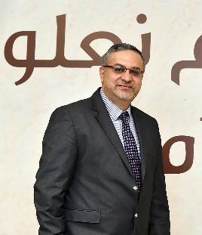
Research Area
Drug Discovery and Development, Drug and Pharmaceutical Analysis and Analytical and Quality Accreditation.

Prof. Alali was born in Dűsseldorf, Germany to a Jordanian family, married and a father of four children. Prof. Alali holds a Bsc in Pharmacy, Jordan University of Science and Technology (JUST) in 1992 (Excellent GPA), PhD in Medicinal Chemistry and Molecular Pharmacology/Chemistry of Natural Products 1994-1999, Purdue University (Top 10 USA Schools), Indiana (GPA 3.9/4.0). As of 9/2024, Prof. Alali is the Director of Research and Graduate Studies, QU Health, Qatar University, overseeing research and graduate studies at the Colleges of Medicine, Pharmacy, Dentistry, and Health Sciences. Dr Alali served in this same capacity in 2016-2021 as well, before serving as the Acting Dean of College of Pharmacy, Qatar University 2021-2024. During which, Dr Alali has established the Office of Research and Graduate Studies, QU Health, helped establish Biomedical and Pharmaceutical Research Unit, consolidate the PhD program, oversee establishment of QU Health College, oversee QU Health ranked for the first time in global and subject ranking, publications and grants witnessed tremendous annual growth. From Sept. 2013-2016, Prof. Alali served as the Associate Dean of Research and Graduate Studies, College of Pharmacy, Qatar University, Doha, Qatar.
Since 2013, Dr Alali is supporting QU in advancing health research, academic quality assurance, strategic planning, intellectual properties, research visibility, graduate programs, policy development and global and subject ranking. Prof. Alali has also served as the Dean of Pharmacy at JUST 9/2011 -9/2013, Dean of Pharmacy, Isra Private University, Amman, Jordan 2008-2009, Director and Founder, Pharmaceutical Research Center, JUST 2004-2007 and 2011-2013, Director, Center of Consultation, Community Services and Continuous Education, Isra Private University, Amman, Jordan 2008-2009, Vice and Assistant Dean, Faculty of Pharmacy, JUST 2000-2007.
Dr Alali served as Practical Training Researcher, Xenobiotic, New Jersey, USA 1998-1999, and Research Leave at Research Triangle Institute, North Carolina in 2004. Dr Alali is an expert in Drug Discovery and Development, Drug and Pharmaceutical Analysis and Quality Accreditation (Certified in IEC/ISO 17025), Certified Technical Assessor, member of Afro-Arab Pharmaceutical Organization for Standardization (APSO). Dr Alali supervised more than 30 Msc and Ph.D graduate students. Dr Alali was appointed as Assistant Professor at JUST in 1999 and promoted to full Professor in 2009 with 103 international, peer-reviewed publications, two book chapters and two USA patents.
Dr Alali was awarded the Highest National Recognition Award in Science - Pharmacy in Jordan in 2008 (Royal Decree). Currently, 2025, Dr Alali’s Elsevier Scopus h index is 30 with 3877 total citations, and Google Scholar h index of 36 and i10-Index of 78 with 6367 total citations. His research is focused on discovery and development of anti-cancer agents from natural resources.

Google Scholar: https://scholar.google.com/citations?user=J8NWBBgAAAAJ

Ahmed Awaisu, PhD  PhD (Clinical Pharmacy), MPharm (Clinical), BPham  Professor of Clinical Pharmacy and Practice  College of Pharmacy  Qatar University  E-mail: aawaisu@qu.edu.qa | 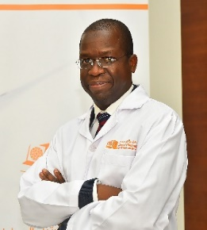
Research Area
Medication use optimization with a focus on medication adherence and burden in chronic diseases; Outcome-based research; pharmacoepidemiology and medication safety and; health promotion
Biography
Ahmed Awaisu is a Professor of Clinical Pharmacy & Practice. He is currently the Head of the Department of Clinical Pharmacy and Practice in the College of Pharmacy at Qatar University. Prof. Ahmed Awaisu has accumulated a prolific record of academic and scholarly accomplishments. He has authored over 180 peer-reviewed publications in international journals, 20 book chapters, and over 200 research abstracts/posters and invited presentations to his credit. His current Google Scholar h-index (September 2022) was 33 [i10-index: 87, Citations: 3,452] and his Scopus Scholar Metrics (September 2022) was: h-index [23], (Citation overview of 167 indexed publications; 1750 total citations by 1502 documents; 340 co-authors). He has successfully supervised about 30 MSc and PhD students internationally [from Qatar University, Universiti Sains Malaysia, Robert Gordon University (UK), and the University of Auckland (New Zealand)].
Prof. Awaisu was the recipient of the “Qatar University Merit Award for Outstanding Faculty” in September 2017 and the “Qatar University Research Excellence Award in Medical, Biomedical and Health Sciences” in April 2019. He was also the recipient of the “Best New Investigator Award” during the 14th International Society for Pharmacoeconomics and Outcomes Research (ISPOR) Annual European Conference in Madrid, Spain in November 2011. He has served as the World Health Organization (W.H.O.) Lead Consultant for reviewing the health system development for Malaysia (2012 – 2013). He was also the recipient of the University Science Malaysia’s Award for Publication Excellence in 2008 and the Best Poster Award, TB and Lung Disease Symposium, Malaysia 2010.
Ahmed Awaisu was formerly the Associate Editor of the journal Value in Health Regional Issue (CEWAA). He is also the Section Editor (Clinical Pharmacy) for the new Elsevier-published textbook entitled “Encyclopedia of Pharmacy Practice and Clinical Pharmacy”. In addition, Dr. Awaisu is the Editor of a textbook that is in writing process, entitled “Health Literacy in Medicines Use and Pharmacy: A Definitive Guide”.
Prof. Ahmed Awaisu is a very passionate and outstanding scholar who always strives for academic excellence in teaching and learning, research, scholarship, and service. His vision is to make sustainable impact in the society through grooming competent healthcare professionals, mentoring novice researchers, high-impact innovative research, and advancing healthcare.

Google Scholar: https://scholar.google.com/citations?hl=en&user=LsFfFbYAAAAJ&view_op=list_works&sortby=pubdate
SCOPUS: https://www.scopus.com/authid/detail.uri?authorId=25624446500
ResearchGate: https://www.researchgate.net/profile/Ahmed_Awaisu

Name Prof. Abdelali Agouni  Academic degrees BSc, MSc, PhD  Academic rank Professor  College Pharmacy  Address Ibn Albitar Building, Qatar University  E-mail aagouni@qu.edu.qa | 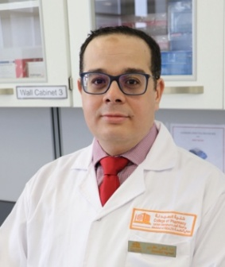
Research Area
- Molecular mechanisms underpinning cardiovascular dysfunction in diabetes and obesity
- Biomarkers of cardiometabolic diseases (translational projects) (bench-to-bed projects)
- Drug discovery
Biography
Prof. Abdelali Agouni is currently a Professor of Pharmacology at the College of Pharmacy (Qatar University). Dr. Abdelali graduated with a BSc (Biochemistry) in 2003 and an MSc (Pharmacology) in 2005 from the University Louis Pasteur of Strasbourg (France) and a Ph.D. in clinical and experimental Pharmacology from the University of Angers (France) in 2008. After graduating with his Ph.D., he joined in 2009 the University of Aberdeen (Scotland) as a post-doctoral research fellow at the School of Biological Sciences. In October 2011, he moved to the University of Surrey (England) as a tenured Assistant Professor of cardiovascular biology within the Faculty of Health and Medical Sciences. In 2015, he joined the college of Pharmacy of Qatar University as an assistant professor of pharmacology, and then in 2017, he was promoted to the rank of Associate Professor and in 2022 to the rank of Professor. He is the founding coordinator of the Ph.D. program in pharmaceutical sciences. Dr. Abdelali is also visiting professor at the University of Jordan and the University of Sao Paulo (Brazil).
Dr. Abdelali is an expert in cardiovascular and metabolic functions phenotyping (60 peer-reviewed publications in internationally leading journals to date, h-index of 26, and total citations of over 2,680) and a strong experience in investigating intracellular signaling pathways using both cellular and transgenic animal models of obesity, diabetes, and cardiovascular disease. The major focus of his research to date has been to gain a better understanding of the mechanisms linking obesity and diabetes to cardiovascular complications. He is also heavily involved in multidisciplinary drug discovery projects. Dr. Abdelali has successfully managed several competitive research grants involving teams inside and outside of Qatar. He is currently an investigator on multiple active grants with a cumulative research income of over $2 million in the past 5 years.
Dr. Abdelali has successfully supervised to completion many undergraduate, 4 MSc, 7, and Ph.D. students inside and outside of Qatar University. Dr. Abdelali has a very well-equipped and funded lab and his research team currently consists of:
- 2 Ph.D. students
- 1 MSc student
- 3 research assistants
- 1 Post-Doc fellow will join in 2023
- 1 new research assistant will join in 2023
He currently holds several major active grants:
- NPRP11S grant (QNRF) 2020-2024
- NPRP14S grant (QNRF) 2022-2026 ($535k)
- QU internal grant 2022-2023 ($60k)
- HMC grant 2023-2024 ($60k)
- UREP29 grant (QNRF) ($30k)
- QU Post-doc Grant 2023-2024 ($190k)
PubMed: https://pubmed.ncbi.nlm.nih.gov/?term=agouni+a&sort=date
Google Scholar: https://goo.gl/CdVTSk
https://scholar.google.co.uk/citations?user=L_SGjuwAAAAJ&hl=en

Name Dr. Mohamed Elrayess  Academic degrees BSc, PhD  Academic rank Associate Professor  College Pharmacy, QU Health  Address I03 Building, Qatar University  E-mail m.elrayess@qu.edu.qa | 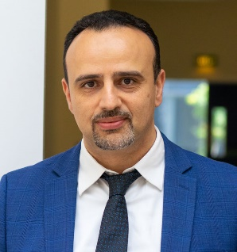
Research Area
- Molecular mechanisms underpinning cardiovascular dysfunction in diabetes and obesity
- Biomarkers of cardiometabolic diseases (translational projects) (bench-to-bed projects)
- Drug discovery

Biography

Dr Mohamed Elrayess has a PhD in cardiovascular genetics from University College London, United Kingdom, in 2003. He served as a postdoctoral fellow at the Cardiovascular Medicine unit at University College London (2003-2004) where he investigated stem cell therapy in cardiovascular disease, then spent 8 years (2004-2012) as a scientist at Eisai, a top international pharmaceutical company, where he developed skills in drug discovery and development, mainly focusing on stem cell therapy in neurodegenerative disease. He then spent the following 7 years (2012-2019) working as a senior scientist at Anti-Doping Lab Qatar, an international testing laboratory for doping abuse in elite athletes, using various OMICS approaches for the identification of novel biomarkers of insulin resistance and diabetes and investigating genetics and metabolomics of elite athletes.

Dr Elrayess has joined Qatar University in 2019 as a research assistant then associate professor at the Biomedical Research Center where he leads the OMICS research group. His research is focused on investigating novel therapeutic targets in insulin resistance and diabetes as well as sports OMICS research. He has over 60 publications, supervised 3 PhD students and a number of MSc students and raised more than 3 million USD research funding. He is currently the director of basic research at QU Health cluster.

PubMed: https://pubmed.ncbi.nlm.nih.gov/?sort=date&term=Elrayess+MA&cauthor_id=36005643
Google Scholar: https://scholar.google.com/citations?user=tiOCu6UAAAAJ&hl=en

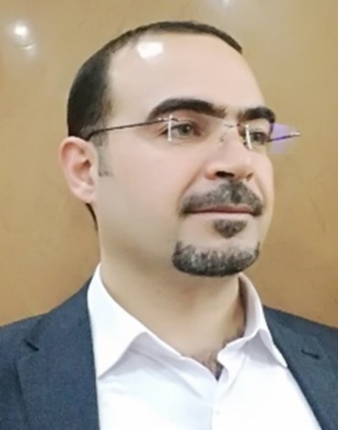
Name Dr. Nizar Al-Shar’i
Academic degrees BSc, MSc, PhD
Academic rank: Professor
College Pharmacy, QU Health
Address I03 Building, Qatar University
E-mail: n.alshari@qu.edu.qa

Biography
Dr. Nizar Al-Shar’i is a professor of Medicinal Chemistry and Drug Design in the Department of Pharmaceutical Sciences at the College of Pharmacy, Qatar University (QU), Doha, Qatar. He earned a BS Pharm degree in 2001 and an MPharm in medicinal Chemistry in 2007 from the Faculty of Pharmacy, Jordan University of Science and technology (JUST), Irbid, Jordan. In 2013, he graduated from Strathclyde Institute of Pharmacy and Biomedical Sciences (SIPBS), University of Strathclyde, Glasgow, UK, with a PhD in Medicinal Chemistry and Computer-Aided Drug Design, and then he joined the Faculty of Pharmacy at JUST as a full-time lecturer. In April 2013, he was promoted to assistant professor, then to associate professor in June 2018, and in April 2023 he was promoted to full professor.
During that time, he was appointed to many administrative positions. He started as an assistant dean for postgraduate and quality assurance affairs, then as a chairperson for the department of medicinal chemistry and pharmacognosy, and finally as a vice dean for accreditation and quality assurance where he was in charge of the ACPE accreditation file. Meanwhile, he also chaired many institutional committees such as assessment committee, accreditation and quality assurance committee, and participated in many committees such as strategic planning, scientific research, postgraduate studies, to name a few.
In terms of research, he interested in drug discovery via applying Computer-Aided Drug Design (CADD) methods, and Molecular Dynamics (MD) Simulation. He also published many articles (over 50) in peer-reviewed international indexed journals. He has a firm believe that the integration of experimental and theoretical approaches, particularly through CADD and molecular modeling, provides unparalleled insights into the systems under investigation which are pivotal for advancing drug discovery.

PubMed: https://pubmed.ncbi.nlm.nih.gov/?term=Al-Shar%27i+NA&cauthor_id=38925196&size=200
Google Scholar: https://scholar.google.com/citations?user=tL53ex0AAAAJ&hl=en


Name Dr. Zaheer Ud-Din Babar
Academic degrees BSc, MSc and PhD
Academic rank: Professor
College Pharmacy, QU Health
Address I03 Building, Qatar University
E-mail: z.barbar@qu.edu.qa

Biography
Professor Zaheer Babar is the Professor of Clinical Pharmacy and Practice at the College of Pharmacy, Qatar University, and a Visiting Professor at the Department of Pharmacy, University of Huddersfield, United Kingdom. His previous academic positions include Professor in Medicines and Healthcare and Director of Pharmaceutical Policy and Practice Research Centre, University of Huddersfield, UK (2017-2023), and Head of Pharmacy Practice, University of Auckland, New Zealand (2007-2016). He is widely acclaimed for his work in policy and practice, particularly in the areas of quality medicine use, medicine access, and pricing.
He has authored over 330 papers and is regarded as the leading researcher in the “pharmacy practice research category” in both Google and Scopus rankings. His publications have appeared in highly respected journals such as PLoS Medicine and The Lancet.
He has served as a consultant for various organizations, including the World Health Organization, Royal Pharmaceutical Society, United Nations Development Programme (UNDP), Health Action International, MSH, International Union Against Tuberculosis and Lung Disease, World Bank, European Union, International Pharmaceutical Federation (FIP), and the Pharmaceutical Management Agency of New Zealand.
Professor Babar’s edited works include “Economic Evaluation of Pharmacy Services,” “Pharmaceutical Prices in the 21st Century,” “Pharmaceutical Policies in Countries with Developing Healthcare Systems,” “Global Pharmaceutical Policy,” “Access to High-Cost Medicines,” “Pharmacy Practice Research Methods,” “Pharmacy Practice Research Case Studies,” and “Encyclopedia of Pharmacy Practice and Clinical Pharmacy.” His most recent publication is “Encyclopedia of Evidence in Pharmaceutical Public Health and Health Services Research in Pharmacy.”
He is the founding editor-in-chief of the Journal of Pharmaceutical Policy and Practice, a high-impact publication providing evidence-based insights and recommendations for policymakers, practitioners, and researchers. He is passionate about advancing the quality, equity, and sustainability of healthcare systems and improving health outcomes for people around the world.

Scopus: https://www.scopus.com/authid/detail.uri?authorId=57222325633

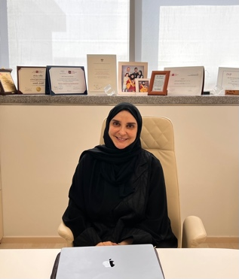
Name Dr. Banan Abdulrzaq S Mukhalalati
Academic degrees BSc,…………………
Academic rank: Professor
College Pharmacy, QU Health
Address I03 Building, Qatar University
E-mail: banan.m@qu.edu.qa

Dr. Mukhalalati is an Associate Professor in the Clinical Pharmacy and Practice Department in the College of Pharmacy at Qatar University and the Director of Integrated Learning Office in the QU Health. Dr Mukhalalati received her BSc in Pharmacy from King Saud University in Saudi Arabia, and her MBA from Qatar University, before doing her PhD in the University of Bath in UK. Dr. Mukhalalati joined QU as a Founding Assistant Dean for Faculty and Student Affairs in 2009. Dr Mukhalalati has been appointed by FIP as a Global Lead for the 3rd FIP Development Goal "Quality Assurance" in 2019. Dr Mukhalalati is also an active member of the Academic Pharmacy section in FIP. In 2020, Dr Mukhalalati graduated from the Executive Leadership Program by Qatar Leadership Center and recently she graduated from Qatar University Teaching in Higher Education Fellowship in collaboration with Harvard Graduate School of Education at Harvard University
Dr. Mukhalalati’s research interests are in the areas of learning theories, health profession education, preceptors’ professional development, cultural competence, capacity building, and disaster management. She has established research collaborations with prestigious institutions both locally and globally, has more than 25 publications in the areas of health profession education and research, and has been involved in supervising MSc students. She has received more than 15 intramural and extramural research funding (from QU and QNRF) as a lead principal investigator. She has also presented more than 35research abstracts as posters, and podium presentations in local, regional, and international conferences, symposia, and workshops.
Google Scholar: https://scholar.google.com/citations?user=j6K3pc4AAAAJ&hl=en
ORCID: https://orcid.org/0000-0002-0049-8879
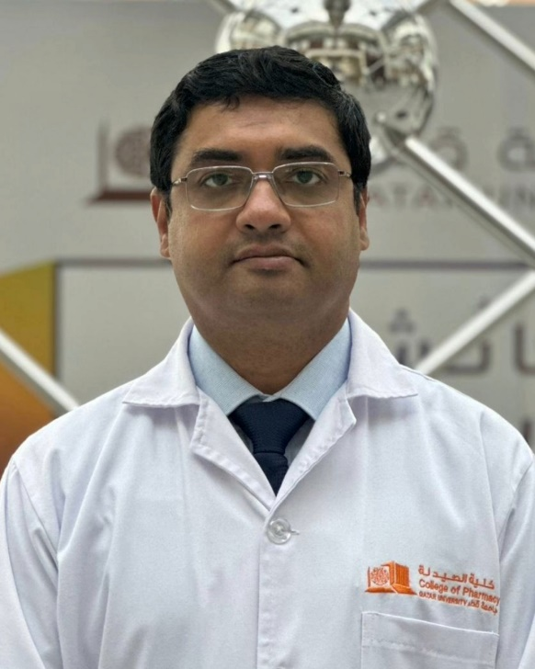
Name Dr. Sowndramalingam Sankaralingam
Academic degrees: BSc, MSc and PhD
Academic rank Associate Professor
College Pharmacy, QU Health
Address I03 Building, Qatar University
E-mail : sownd@qu.edu.qa

Biography
Dr. Sownd Sankaralingam received his MBBS degree from the Tamil Nadu Dr. M.G.R Medical University, Chennai, India in 2002. He completed an MSc in Pharmacology from the University of Saskatchewan, Canada in 2004 with thesis on the role of 20-HETE in salt-sensitive hypertension. Subsequently, he obtained his PhD degree from the Department of Physiology, University of Alberta, Canada in 2009 for his thesis on the mechanisms of endothelial cell oxidative stress in preeclampsia. During this time, he received studentships from the Alberta Heritage Foundation for Medical Research and the Heart and Stroke Foundation of Canada. As an Alberta Innovates Health Solutions funded post-doctoral fellow (2011-2014) at the University of Alberta he investigated the alterations in cardiac energetics (energy metabolism) in cardiac hypertrophy and heart failure. Subsequently, he completed a clinical research fellowship in the Department of Medicine with focus on hypertension.
His research focuses on pharmacist-involved care in cardiovascular diseases including hypertension and diabetes. He is currently investigating validation status of blood pressure monitoring devices sold in community pharmacies and pharmacist preparedness to be involved in home blood pressure monitoring. His research interests include use of digital technology for cardiovascular risk management.
Dr. Sownd has published more than 25 peer-reviewed articles and has presented his work at several national and international conferences. His research is funded by grants from Qatar University and QNRF.

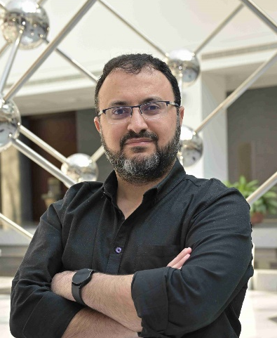

Name Dr. Hesham Al-Sallami
Academic degrees: BSc, MSc and PhD
Academic rank Associate Professor
College Pharmacy, QU Health
Address I03 Building, Qatar University
E-mail : H.Al-sallami@qu.edu.qa

Hesham Al-Sallami is an associate professor of clinical pharmacy practice. He joined the college in 2024 and teaches into the undergradaute, PharmD, and master’s pharmacy programmes.
Originally from Yemen, I trained as a clinical pharmacist in New Zealand and obtained a master’s in clinical pharmacy practice from the University of Otago. I have 16 years’ experience in clinical pharmacy/pharmacotherapeutics teaching, practice, and research.
I hold a PhD (University of Otago) in quantitative clinical pharmacology and pharmacometrics. My research interests include drug dose individualisation in special populations, with a focus on paediatrics and in obesity. My work involves the development of dosing guidelines and dose calculation tools for medicine dosing in special populations.
I have a particular interest in the pharmacotherapeutics of cardiovascular, coagulation, and endocrine diseases. This interest stems from my research expertise and experience in drug dosing related to these conditions. I have also developed, taught, assessed, and evaluated topics in clinical pharmacokinetics, and I have a particular interest in clinical PK modelling and therapeutic drug monitoring.
In terms of service, I was involved in the development of a modular BPharm curriculum and was a member of the undergraduate programmes, curriculum review, postgraduate programmes, research, and admission committees. I held the role of associate dean in pharmacy practice and admissions and I have experience in aligning student selection and admissions with the needs of the pharmacy health workforce in New Zealand.
My other notable service role is being a clinical pharmacology expert advisor to healthcare regulatory agencies. The role involved reviewing dose selection and dosing in special populations of new drugs entering the Oceania markets.

PubMed: https://pubmed.ncbi.nlm.nih.gov/?term=Hesham+Al-Sallami+&sort=pubdate&size=200
Google Scholar: https://scholar.google.co.nz/citations?user=nEEJadgAAAAJ&hl=en

