Digital Measures Questions

How do I log in to my account?

1. Go to the log in page or you can click this link https://digitalmeasures.com/login/qa-qu/faculty

If you forgot your password, follow the following steps after going to the log in page above:

- Click on the ‘Need help?’
- Click ‘Reset Your Password‘.
- Enter your username, then click ‘Reset Password’. You will receive an email, kindly check your inbox.

2. Log in using your QU username Digital Measures Password.

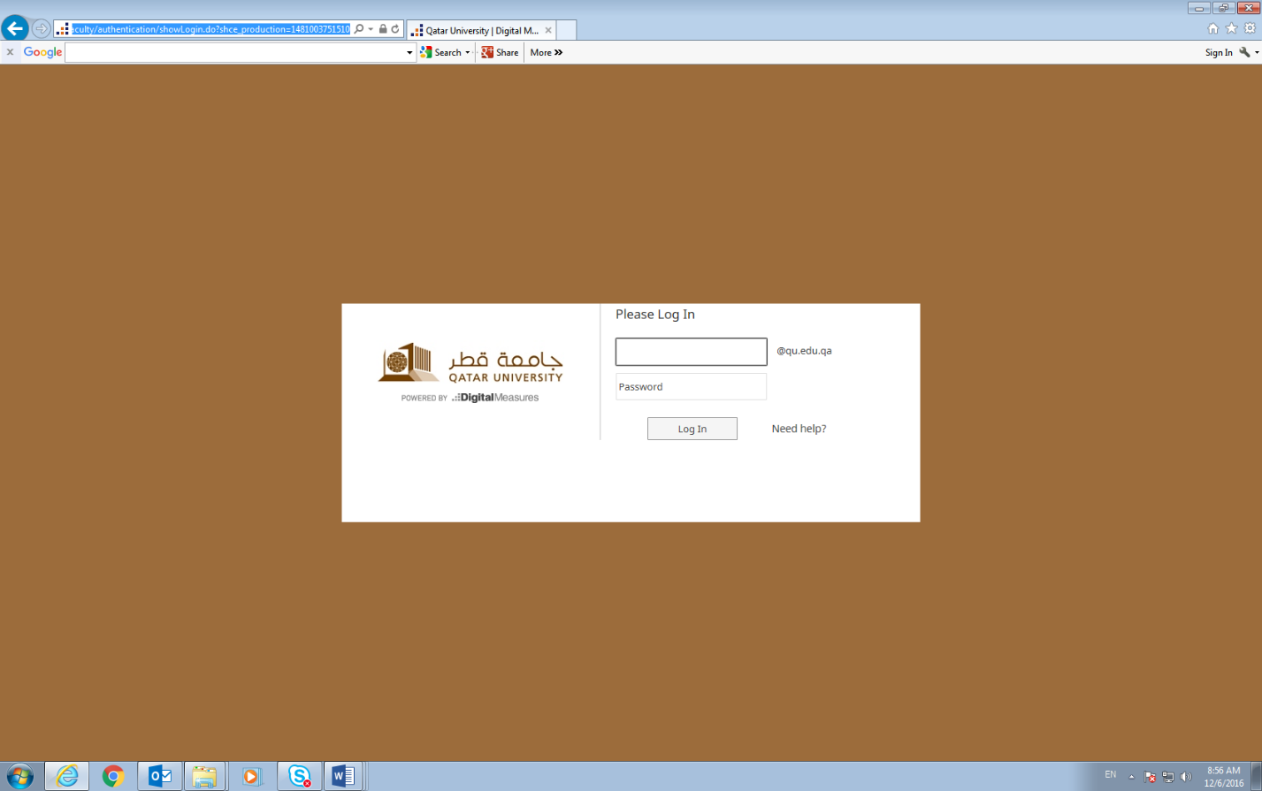

How to Run Faculty Reports in Digital Measures
How do I submit my ‘Annual Faculty Performance and review’ report for my annual evaluations?
- After uploading all your activities in the relevant screens (deadline February 8, 2018), go to ‘Run Reports’ on the left hand side panel:
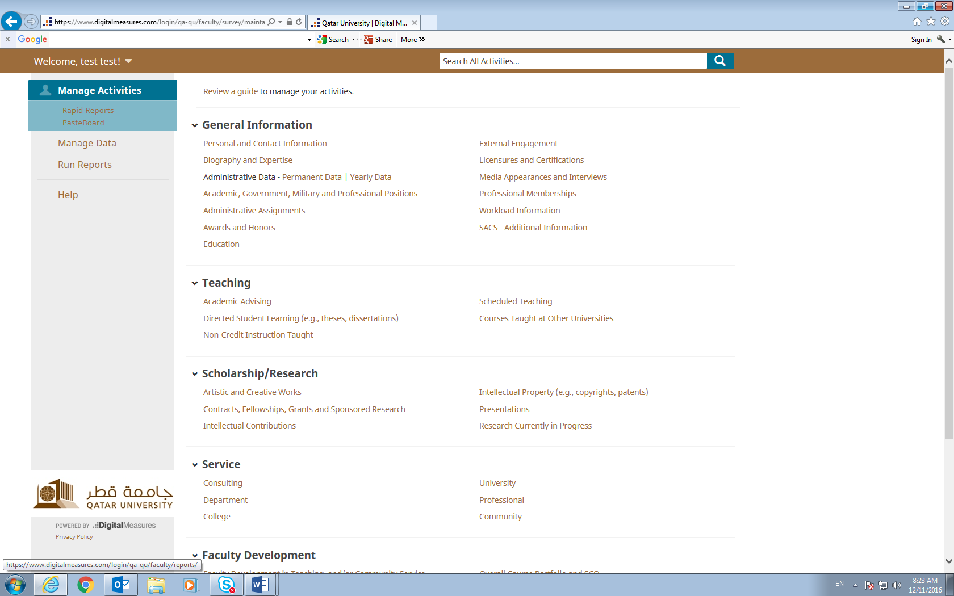
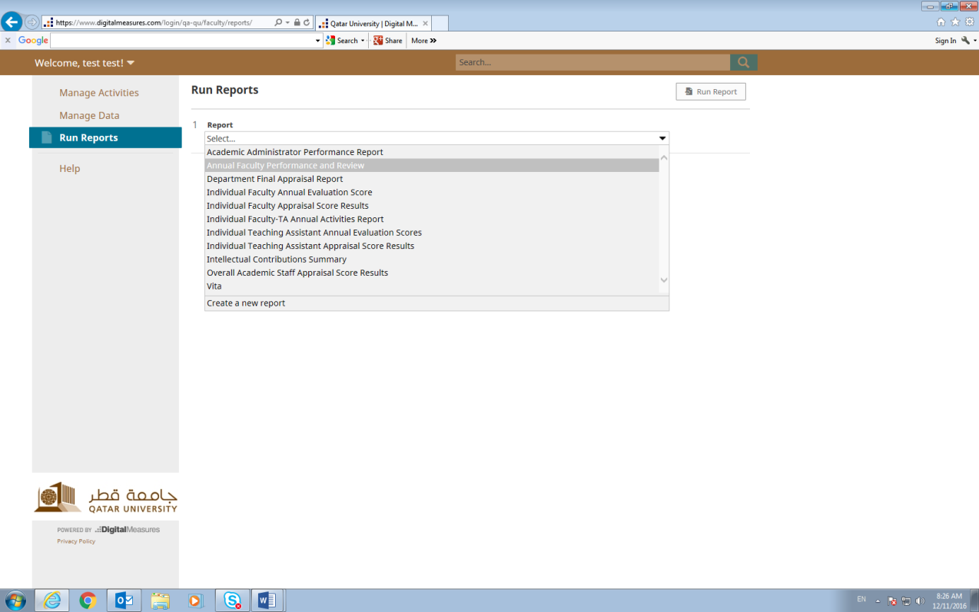
- Choose ‘Annual FacuChoose “Annual Faculty Performance and Review’ from the drop down menu:

- Choose the date January 1, 2017-Decemebr 31, 2017 and the file format you want (Word or PDF). Click on ‘Run Report’
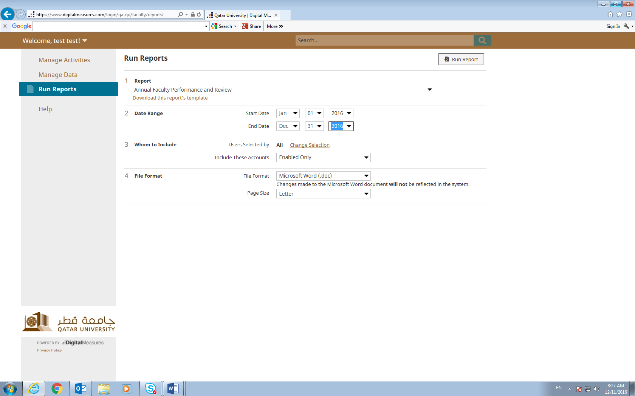
- Open and Save the report on your desktop and go to ‘Annual Appraisal’ In Manage Activities and click on ‘Annual Faculty Performance and Review’:
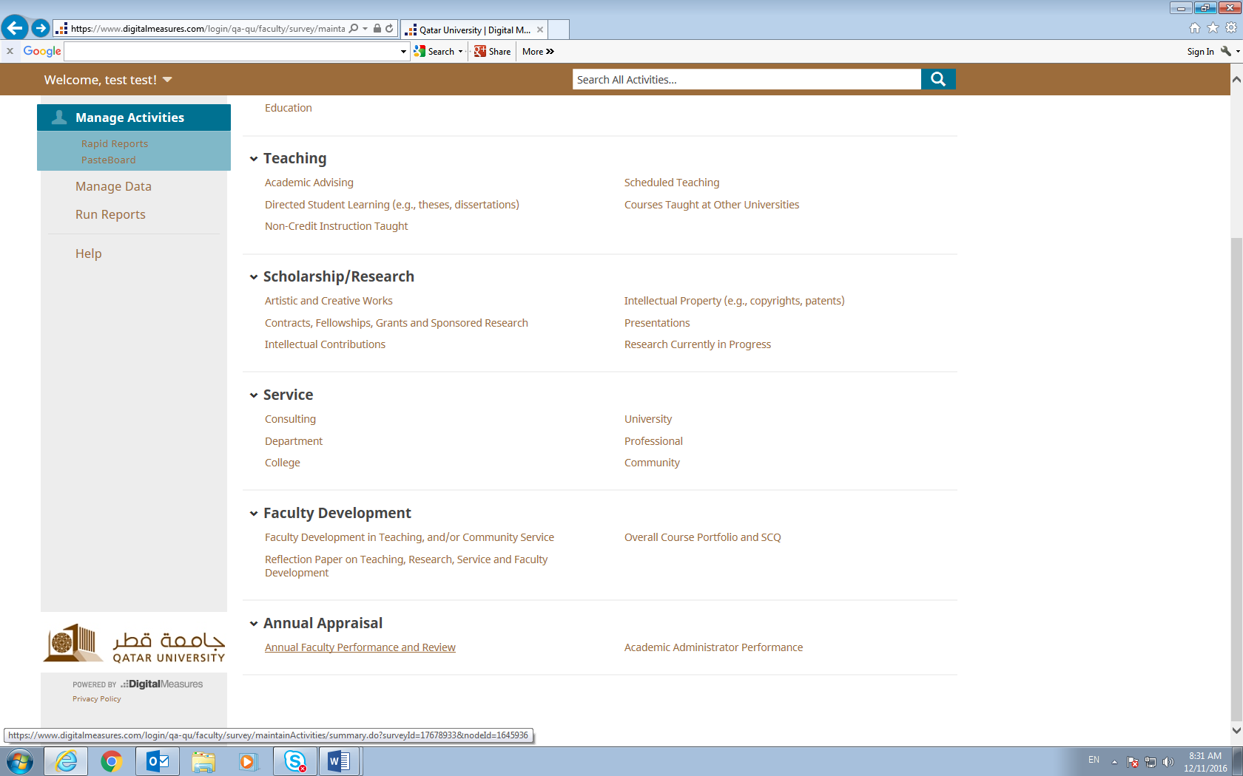

- Choose ‘2017’
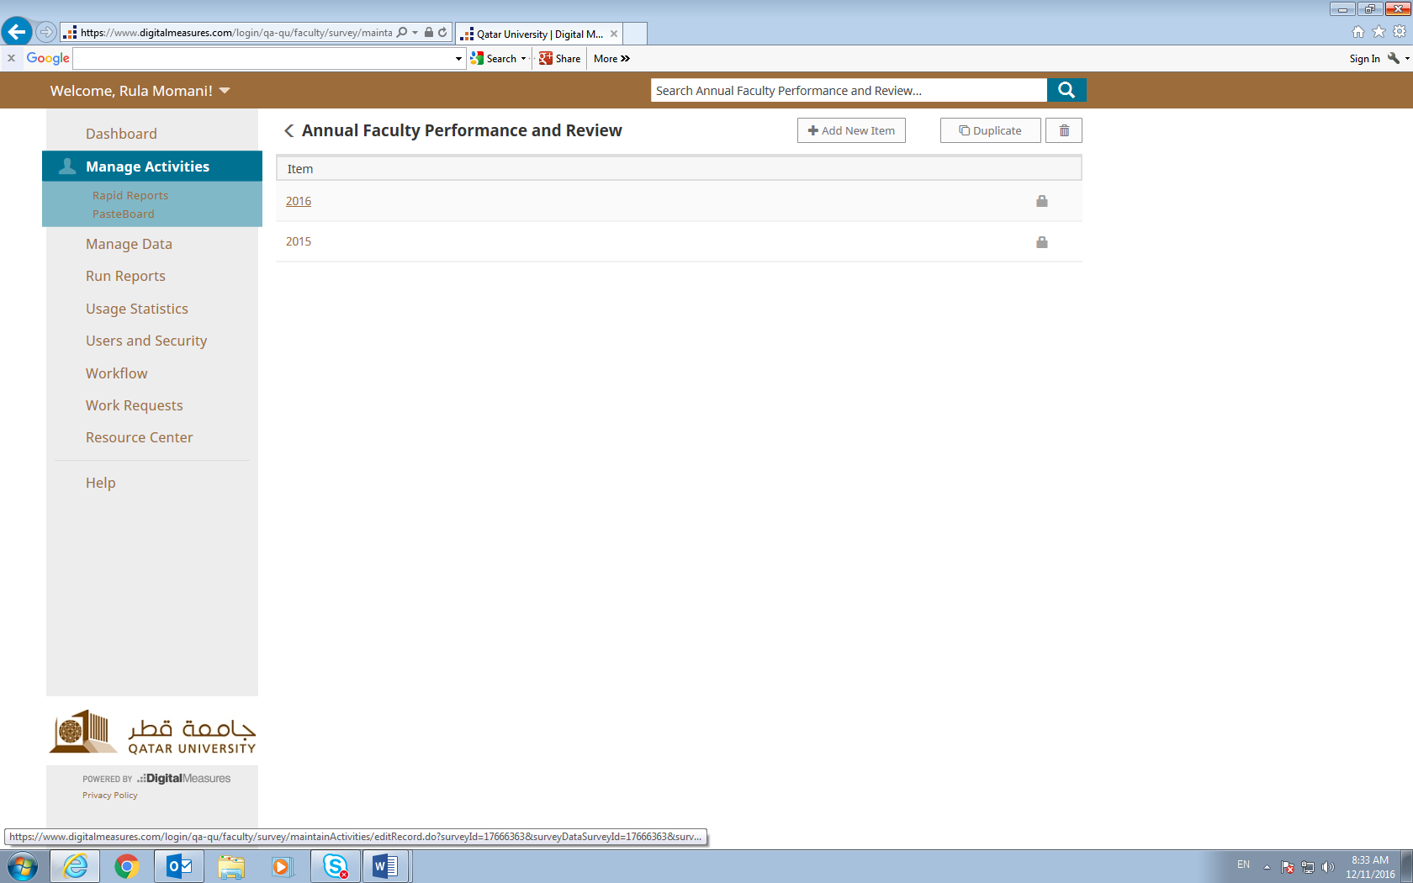
- Upload the Annual Faculty Performance and Review report you saved on your desktop and enter today’s dates below and save:
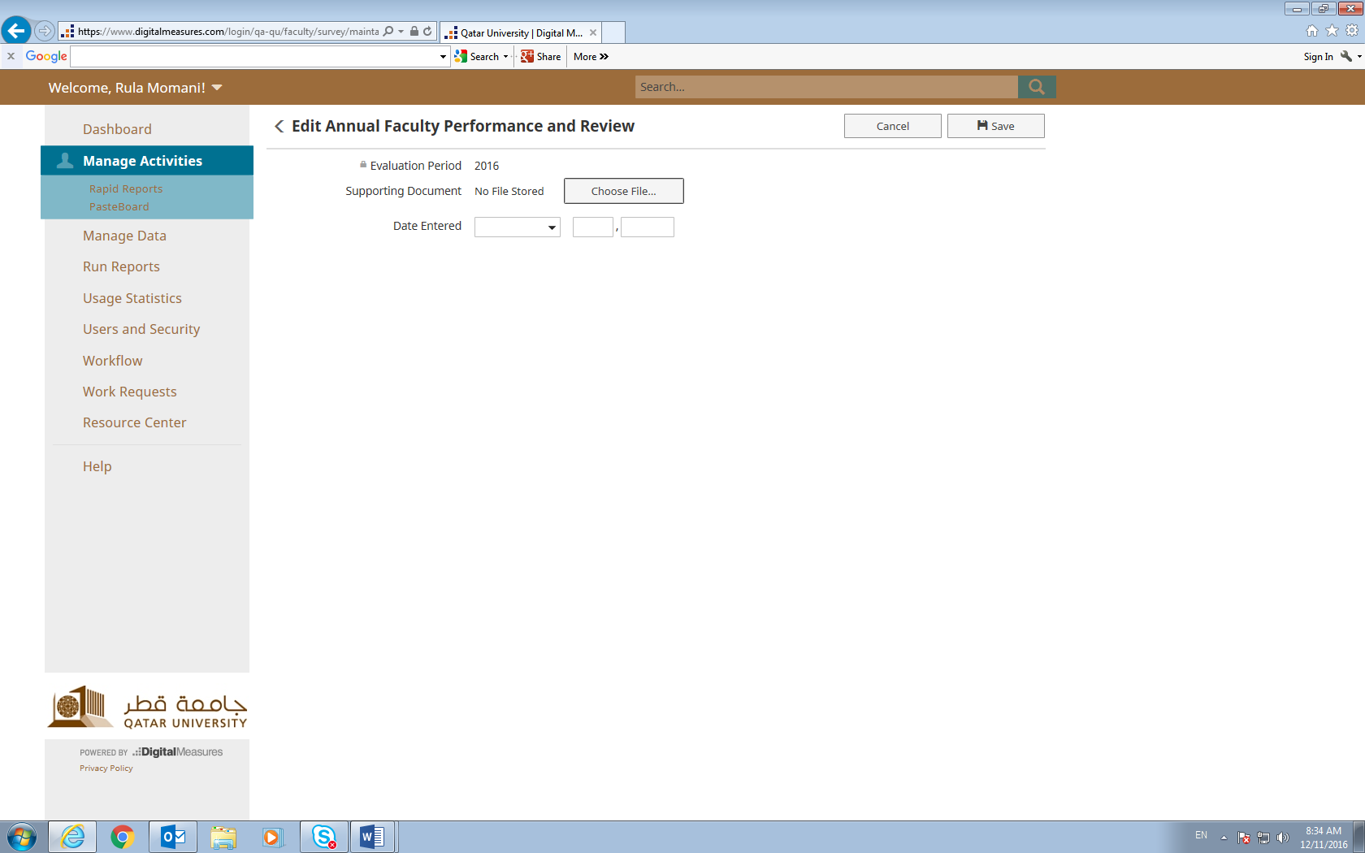

How can I check my evaluation results?
- After April 5, you can check your appraisal score by going to ‘Run Reports’ in Activity Insight (same as step 1 above) and choosing ‘Individual Faculty Annual Evaluation Score’:
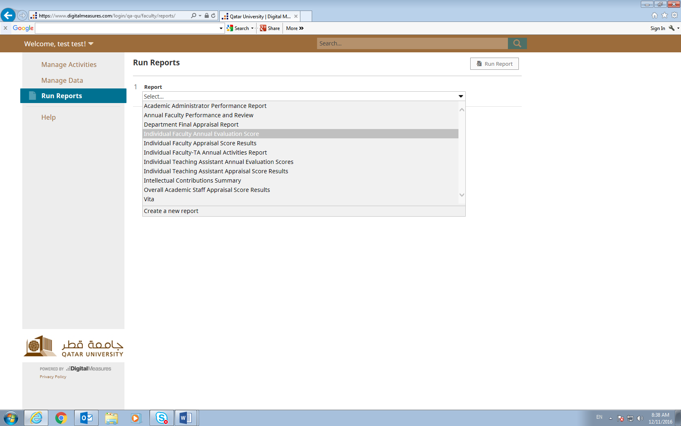
- Choose the evaluation period dates from January 1, 2017- December 31, 2017 and choose the desired file format and page size and click on ‘Run Report. Open file.

